1. **Introduction** . The tool utilized for code review and grading purposes is an open-source extension for Visual Studio Code named Code Review.

It has a variety of features that do not apply to our purpose of grading feedback, but it is quite easy to use for our purposes.

1. **Hot to install it**? In Visual Studio Code go to the „Extensions”--> Section and search for Code Review --> there you will have a button to install it . (#1 Photo)

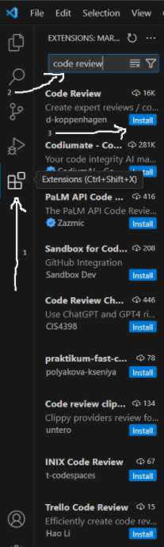 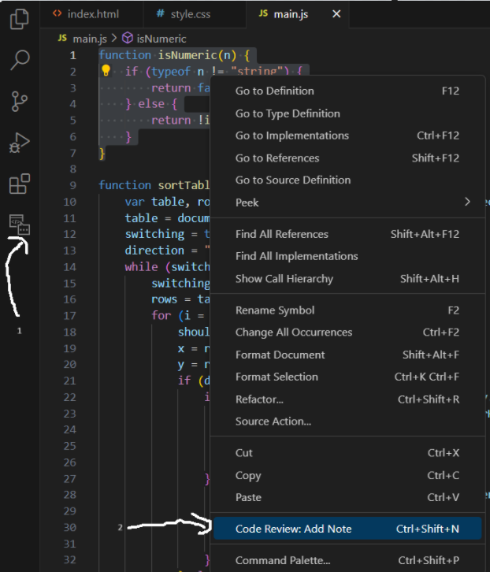 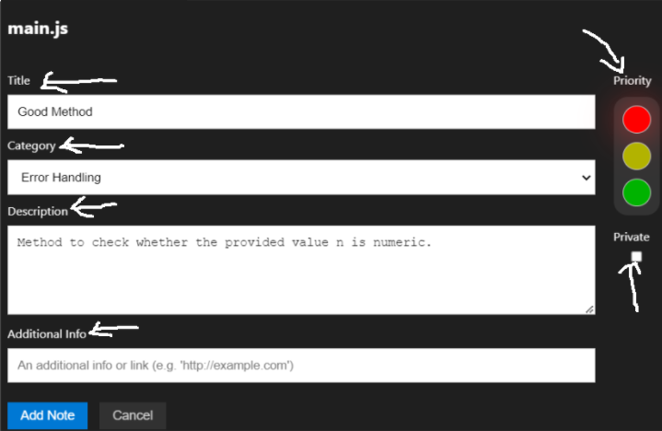

1. **How to easily use it** ? Comments are made by selecting the code, right-clicking, and choosing "Code Review: Add Note" from the context menu (#2 Photo) . Each comment includes a title, category, priority, description, and space for additional notes (#3 Photo) . Once all comments are made, we export a report in HTML format using the extension's options.
2. **Customisation (#4 Photo)** . The tool's category list and report format can be customized to better suit educational feedback needs. Initially, the default categories were tailored for professional code review, but anyone can modify them in order to align with their needs. This modification was simple, as categories can be easily edited within the extension settings 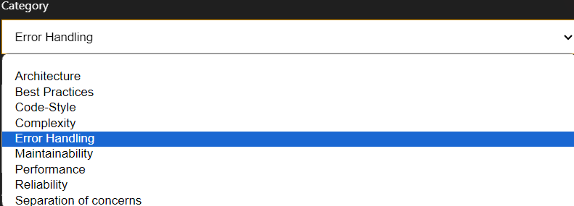
3. **The benefits in the end?** In the end the code should looke like this after the Code Review is added (#4 Photo) . The use can easily see the comments written for the code and also the priority

